Lab Test-04
SET-B
Question 1:
Refactor Nested Conditional Statements Task: You are given the following legacy code that determines discounts based on customer type and purchase amount:
def calculate_discount(customer_type, amount):
if customer_type == "regular":
if amount > 5000: discount = amount * 0.05
else:
discount = 0
else:
if amount > 3000: discount = amount * 0.10
else:
discount = amount * 0.05 return amount – discount
Your task: Use an AI-assisted code tool to refactor the function by: 1. Simplifying nested if-else statements for better readability. 2. Introducing cleaner logic using dictionaries or guard clauses. 3. Adding meaningful docstrings and inline comments. Instructions: • Verify the correctness by testing multiple input cases. • List the AI’s key refactoring suggestions and explain how they improved maintainability.
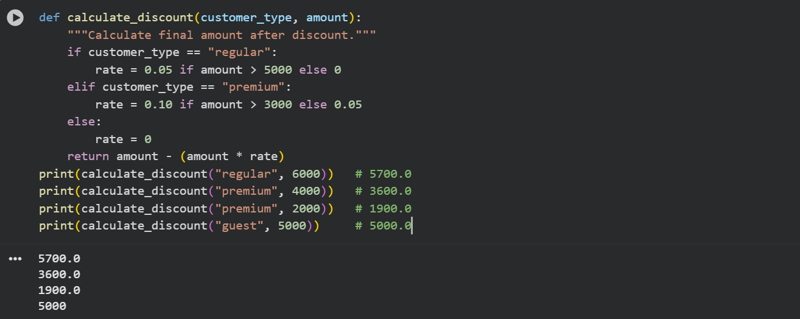
Explanation:
Purpose:
This function calculates the final amount a customer pays after discount based on their type and purchase amount.
Simplified Logic:
Used inline conditions (x if condition else y) instead of nested if-else, making the code short and clear.
How it Works:
- Regular customer: 5% discount if amount > 5000, else no discount.
- Premium customer: 10% discount if amount > 3000, else 5%.
- Other types: No discount.
Return Value:
Returns the final amount after subtracting the discount.
Formula: final_amount = amount - (amount * rate)
Why It’s Better:
- No nested if-else (clean code).
- Easy to add more customer types later.
- Simple, readable, and easy to maintain.

Question 2:
Refactor Repetitive Code Using Functions Task:
The following script calculates total sales for different product categories but repeats logic unnecessarily:
electronics = [1200, 1500, 1000, 800]
clothing = [500, 700, 600]
groceries = [200, 150, 180, 220]
total_electronics = 0 for e in electronics: total_electronics += e total_clothing = 0 for c in clothing: total_clothing += c total_groceries = 0 for g in groceries: total_groceries += g print("Total Electronics:", total_electronics) print("Total Clothing:", total_clothing) print("Total Groceries:", total_groceries) Your task: Use AI-assisted refactoring to: 1. Remove repetitive code by creating reusable functions or loops. 2. Make the script scalable for any number of categories. 3. Apply modern Python practices (e.g., sum(), dictionary iteration). Instructions: • Compare old and new code performance and readability. • Document which AI-generated improvements you used.
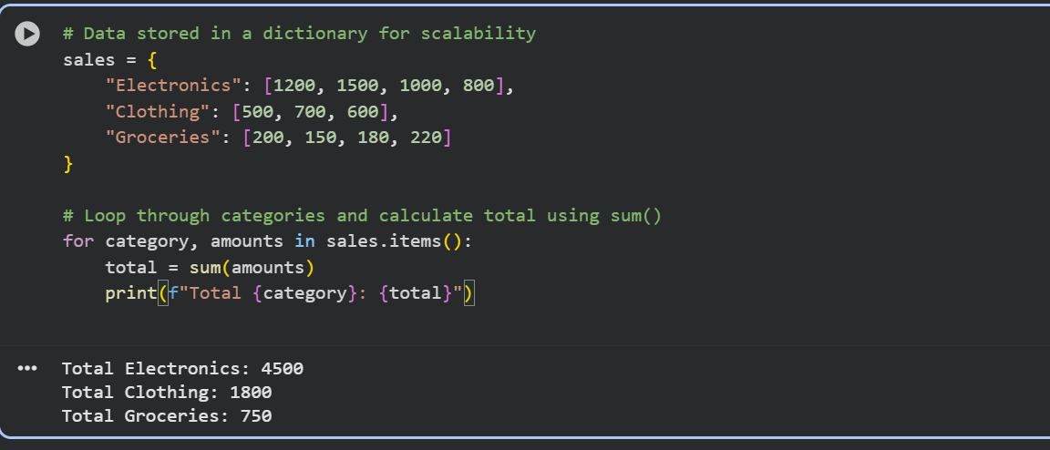
Explanation:
- Removed repetitive code:
Used one loop with a dictionary instead of separate loops for each category.
- Scalable design:
You can add new categories easily — they’ll be included automatically.
- Modern Python features used:
  - sum() to calculate totals quickly.
  - for category, amounts in sales.items() for clean looping.
  - f-strings for clear output.

Performance & Readability
- Old code: Long and repetitive.
- New code: Short, clean, and easy to update.

AI Improvements
- Used dictionary to group data.
- Used sum() for simplicity.
- Used f-strings for neat printing.

